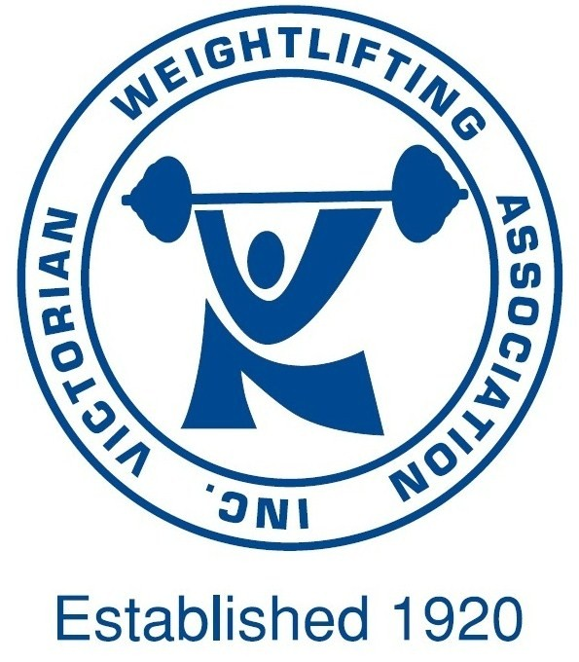 | Victorian Weightlifting Association Inc.  ABN: 14 246 625 815 REG. NO: A0001425X  PO Box 7, HAWTHORN 3122 Victoria Australia  Phone 03 9819 5599  Email: office@vicweightlifting.com | 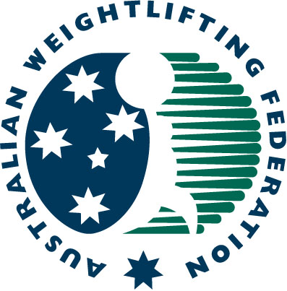

CLUB AFFILIATION 2022

TAX INVOICE

Club/School:
Street Address:
Suburb: |  |  | Post Code:
Postal Address:
Suburb: |  |  | Post Code:
Primary Contact: | Phone No(s):
Email:
Website (if applicable):
Secretary:
NCAS Primary Coach: | Level: | NCAS License Expiry:
Office Bearers (A minimum of 3 Office Bearers are required, 1 must be a VWA member):
1)
2)
3)
Other Information to be listed on AWF website i.e. opening hours, fees etc.

2022 Club Affiliation Fee: $180 (inc GST)
Please Note: Individual membership applications will not be processed until Club Affiliation fee is paid.
Signature (of Club official): |  |  | Date:
Name of Club official:

PAYMENT METHOD - Please Tick
Electronic Funds Transfer (EFT)
Direct Deposit
VWA Account Details for EFT and Direct Deposit
Bank: Commonwealth Bank
Account Name: Victorian Weightlifting Association Inc.
BSB & Account Number: 063187 10169134
Reference: YearClub Name

Your Obligations:

As a registered VWA Affiliate Club you agree that your Club and its members, both athletes and coaches, will be bound by the Statutes and Regulations and Australian Weightlifting Federation (AWF) Rules at all times, including, but not limited to the AWF Anti-Doping Policy and amendments to this policy as they arise. As a Club you agree that your athletes and coaches will comply with the Australian Sports Anti-Doping Authority (ASADA) Act and Regulations which includes in- and out-of-competition drug testing by ASADA or other agency as nominated by the Australian Sports Commission.

All Club members who are also VWA members are subject to, but not limited to, the following under the AWF Anti-Doping Policy:

- In- and-out-of-competition drug testing by ASADA.
- Registered Testing Program (RTP) or Domestic Testing Program (DTP) where athletes are to be notified directly by ASADA.
- Athletes Whereabouts including personal contact details and training venue details which must be updated immediately if changed by contacting office@vicweightlifting.com.

All Clubs are encouraged to direct their members to the AWF Anti-Doping Policy which can be found at http://awf.com.au/technical/antidoping.aspx for complete details of the policy.

Club Affiliation Criteria:

The following criteria MUST be met prior to the VWA accepting affiliation:

- The Club must have one (1) NCAS accredited Olympic Weightlifting Coach listed as the Primary Coach who meets the following additional criteria:
  - VWA member
  - Member of Affiliate Club
  - Maintain NCAS Level 1 (or higher) accreditation as long as he/she is listed as Primary Coach.
- Three (3) Office Bearers, one of whom is a VWA member (Office Bearers may be competitor members or coaches).
- Assist at competitions where rostered.

Additional criteria may be set to clubs to ensure successful running of events. These criteria may include (but not be limited to):

- Volunteering at events. (Volunteer Policy)
- Officiating at events.
- Club members progressing their technical official status.

Where clubs wish to affiliate but cannot meet the above minimum criteria, the VWA will work with the Club to meet the criteria in an agreed timeframe.

The Board of the VWA reserves the right to amend the above club affiliation requirements at any time.

For more information please contact the VWA on (03) 9819 5599 or email office@vicweightlifting.com

